Episode 413: The force on a moving charge
Here you can extend the idea of a magnetic force on a current to consider moving charges.

Summary
Demonstration: Bending an electron beam. (20 minutes)
Discussion: Deducing F = Bqv. (30 minutes)
Discussion: Applications of F = Bqv. (20 minutes)
Demonstration: Measurement of e/m for electrons. (20 minutes)
Discussion: Particle accelerators. (10 minutes)
Discussion: Velocity selectors & mass spectrometers. (10 minutes)
Discussion: The Hall effect. (10 minutes)
Discussion: Astronomical applications. (10 minutes)
Student questions: Applications of F = Bqv. (20-40 minutes per set)

Demonstration:
Bending an electron beam
If a fine beam electron tube is available, the sight of the paths left by electrons travelling in a circular path when a magnetic field is applied makes a good introduction to this episode. If the apparatus is not available, then using a magnet to distort a black and white TV picture offers an alternative but avoid a colour TV where lasting damage can occur.

TAP 413-1: Deflecting electron beams in a magnetic field

Discussion:
Deducing F = BeV
Episode 412 talked about the force on a conductor carrying a current in a magnetic field. Any moving charge is an electric current, whether or not the charge is flowing through a material or not. Therefore, it is not unreasonable to expect to find a force on a charged particle moving through space.
Suppose we have such a particle with a charge q, moving at a speed v, at right angles to a magnetic field of flux density B. In a time t, the charge will move a distance L = v × t and is equivalent to a current I = q / t.
Force on the current = BIL = B × q / t × v × t = Bqv
If the field and current are at an angle θ, then the formula will be modified to F = Bqv sin θ
If the particle is moving at right angles to the field, then the left hand rule shows that the force will always be at right angles to the direction of motion. This means that the particle will move in a circle of radius r.
B
e
Centripetal force = Bqv = mv²/r
Momentum = mv = Bqr

Discussion:
Applications of F = Bqv
If we write e for the electronic charge, the equation becomes F=Bev, and you might refer to this as the ‘Bev force’.
There are many applications of this force, several of which can provide interesting experiments or demonstrations. You will need to select those that match the requirements of your specification.

Demonstration:
Measurement of e/m for electrons
Historically this experiment, performed by J J Thomson in 1897, is of great significance. It may be possible for you to repeat his experiment using electric and magnetic field to deflect the electron.

TAP 413-2: Measuring the charge to mass ratio for an electron

Discussion:
Particle accelerators
Linear accelerators make use of an electric field to accelerate particles but other accelerators from the early cyclotron to the modern facilities such as at CERN are 'circular' and make use of magnetic fields. If your specification requires then the operation of the cyclotron will have to be covered.

Discussion:
Velocity selectors & mass spectrometers
There is a wide range of these both of historical and modern interest. Again there is a chance to compare the effects of electric and magnetic fields. If students are studying chemistry, you can draw on their knowledge of mass spectrometers to emphasise the value of these techniques.

Discussion:
The Hall effect
This is worth discussing if your students have used a Hall probe to measure magnetic flux densities in Episode 412.

As electrons move through a piece of n-type semiconductor through which a magnetic field passes, then the electrons experience a force (Fleming's left hand rule) which moves them to one side of the semiconductor slab. An electric field builds up giving a force in the opposite direction. Eventually, the two forces balance such that;
I
Hall voltage (V_{H})
t
cell
Semiconductor wafer
Magnetic field (B)
d
(resourcefulphysics.org)
Bev = Ee since E = V_{H} /d
Bev = V_{H}e/d
So the Hall voltage, V_{H} = Bvd, gives a way of measuring
the B-field.

Discussion:
Astronomical applications
There is a wide range of interesting possibilities here.
Close to home, the motion of electrons in the ionosphere allows radio communication over large distances and leads to the aurora borealis at times of great solar activity.
This solar activity itself is the result of the interaction of charged particles in the Sun with the magnetic fields on and above the Sun's surface.
At greater distances, the acceleration of electrons in the intense magnetic fields of active galaxies and neutron stars is a source of radio and X-ray emissions (amongst others).

Student questions:
Applications of F = Bqv.

Many of these applications can be studied further with the questions that follow.

Deflection with electric and magnetic fields

TAP 413-3: Deflection with electric and magnetic fields

The cyclotron

TAP 413-4: The cyclotron

The Hall effect

TAP 413-5: The Hall effect.

Charged particles moving in a magnetic field

TAP 413-6: Charged particles moving in a magnetic field

TAP 413-1: Deflecting electron beams in a magnetic field

Circular control
Magnetic fields are often used to steer beams of charged particles, in situations from a television tube to a large-scale particle accelerator.
The paths are always helices, circles or spirals, as the force acting on the charged particles within the beam is always at right angles to their velocity
Here you look at circular paths, keeping it simple.
You will need:
- electron deflection tube
- stand for tube
- EHT power supply, 0–5 kV
- power supply, 5 V dc
- rheostat
- Helmholtz pair of coils
- 4 mm leads

Safety
Wire carefully, no bare conductor above 40 V
Although the output form the EHT power supply will not give a fatal shock, it can still make the user jump and is quite unpleasant. Teltron tubes often use male 4mm connectors so the leads must terminate in female (socket) connectors if bare conductors are to be avoided.
The protective resistor in the EHT can not be used here.

Deflecting each electron

The deflection tube uses an electron gun to inject electrons into a region of nearly uniform magnetic field perpendicular to the beam. In this region a magnetic field acts on the charge, producing a uniform acceleration in the direction perpendicular to the magnetic field and to the velocity of the electrons. Each electron experiences an acceleration that is always at right angles to its velocity. You should recognise this as a recipe for circular motion by now.

Think carefully about the effect on the circle of the following changes:
• increasing the accelerating pd in the electron gun.
• increasing the current in the coils producing the magnetic field.
You might like to go further and predict how the curve will change when you double one quantity, then the other, perhaps building a computer model to check your predictions, if that helps.

Below is an image as a reminder of what you have seen. As further reinforcement of the analysis suggested you might like to:
• extract enough data to show that the path followed is a circle.

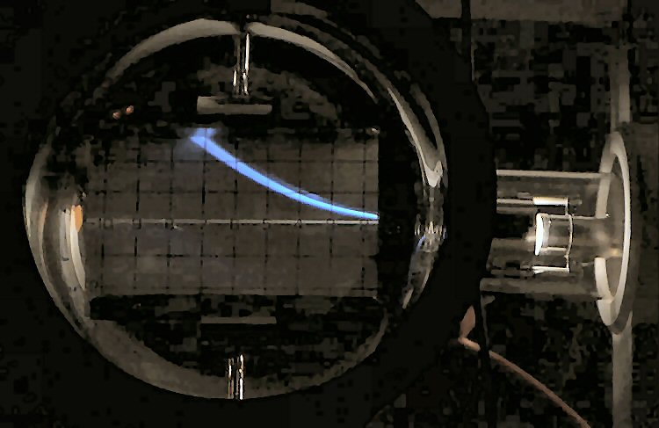

You have
1. Seen electrons in circular motion.
2. Thought about the principles behind this motion.
3. Seen how an accelerating pd can be used to make an electron gun

Practical advice
You will need to set this demonstration up in a well darkened room for maximum effect. You will also want to think carefully about how to display both the tube, in order to explain this action, and the resulting circle, to the size of group that you will be showing it to. It is often a good idea to cover the back of the tube with a black cloth
If new to wiring up electron deflection tubes you may well also wish to practice beforehand, and have a small bench top lamp to hand, well shaded so as not to destroy the dark adaptation of the group’s eyes. You will need to explain and show the actions of the electron gun and the coils, probably using a gimballed bar magnet to show the direction of the field.
You will probably get a spread of circles, perhaps due to the field being non-uniform (a Helmholtz pair only produce an approximately uniform field in the central third of the volume they enclose), due to the electrons provided by the electron gun having a range of velocities, and due to random thermal motion superimposed on the velocity acquired from the action of the accelerating pd.
It may also help to connect both electric deflection plates to the anode in the electron gun and to earth, forcing the filament (cathode) to a large negative voltage.
NB: many low voltage power supplies must not have the output voltage adjusted while delivering high currents.

Safety
Wire carefully, no bare conductor above 40 V
Although the output form the EHT power supply will not give a fatal shock, it can still make the user jump and is quite unpleasant. Teltron tubes often use male 4mm connectors so the leads must terminate in female (socket) connectors if bare conductors are to be avoided.
The protective resistor in the EHT can not be used here.

External references
This activity is taken from Advancing Physics chapter 16, 120D
TAP 413-2: Measuring the charge to mass ratio for an electron

Using circular motion
Using a magnetic field to drive an electron round in a circle can give information about the acceleration.
The magnetic force acting is
$$F = \text{qvB}$$
and the force required to drive it round in a circle is given by
$$F = \frac{{\text{mv}}^{2}}{r}\text{.}$$
You can put these two equal to get
$$\frac{q}{m} = \frac{v}{\text{rB}}\text{.}$$
So three measurements can give the charge / mass ratio of the electron. Both the radius of the circular motion and the magnetic field strength can be measured in a fairly straightforward way. The measurement of the velocity, however, is harder.
Electrons are accelerated by an electron gun. So
$$\text{Vq}=\frac{1}{2}{\text{mv}}^{2}$$
so at first sight it looks as if you need q and m to get started. However, maths comes to our aid, allowing you to combine the two sets of relationships to get
$$\frac{q}{m} = \frac{2V}{r^{2}B^{2}}$$
(arrange both relationships to give v2 then put them equal).
Now we can measure three things in the laboratory in order to find the charge to mass ratio for the electron.
By extension you measure the charge / mass ratio for any charged particle, allowing you to characterise many particles.

You will need:
- fine beam tube
- stand
- HT, 0–150 V
- power supply, 5 V dc
- rheostat
- Helmholtz pair of coils
- 4 mm leads with sprung shrouds for connections to HT circuits (some may need a female termination)

Safety
Wire carefully, no bare conductor above 40 V.
HT supplies are always dangerous, especially so in the dark. Shrouded plug leads MUST be used. No connections should be changed with the power switched on.

Making the measurements
You will need to arrange the magnetic field and accelerating pd so that you can see a complete circular electron path.

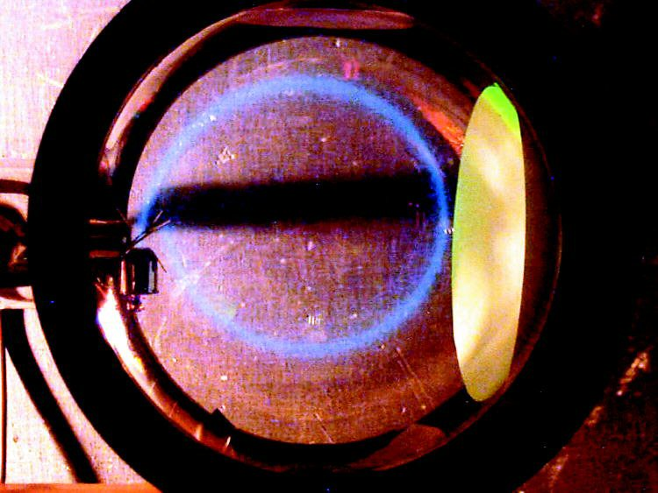

Record the pd and radius of the beam (in metres). Switch off the HT.
Now remove the electron tube to allow the use of a calibrated magnetic field sensor, or a current balance, to measure the magnetic field where the electron beam was.
Now use the relationship
$\frac{q}{m} = \frac{2V}{r^{2}B^{2}}$ to find q/m.

You have
1. Seen an arrangement of electric and magnetic fields that will drive electrons round in a circle.
2. Analysed the motion to give a relationship between q/m and things you can measure in the school laboratory.
3. Made a measurement of q/m.

Practical advice
You will need to set this demonstration up in a well darkened room for maximum effect, more so than that needed for a deflection tube. You will also want to think carefully about how to display both the tube, in order to explain its action, and the resulting circle, to the size of group that you will be showing it to. Try covering the back of the tube with a black cloth
If new to wiring up electron deflection tubes you may well also wish to practice beforehand, and have a small bench top lamp to hand, well shaded so as not to destroy the dark adaptation of the group’s eyes.
You will need to explain and show the actions of the electron gun and the coils, probably using a gimballed bar magnet to show the direction of the field. Make some play of the need to measure the magnetic field separately, using a technique familiar to the students. This is likely to involve the use of a current balance, or a calibrated magnetic field probe. A suitable design of current balance is the following:

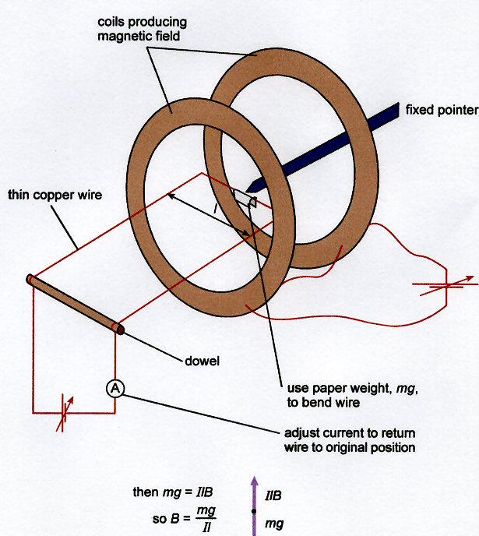

Student ingenuity can be harnessed to estimate the radius of the circle of the electron beam. With prior practice you will, in any case, have a good idea of the values you need to obtain in order to get an approximately correct value of q/m – about 1.8 x 10¹¹ C kg^{–1}.

You will probably get a spread of circles, perhaps due to the field being non-uniform (a Helmholtz pair only produce an approximately uniform field in the central third of the volume they enclose), due to the electrons provided by the electron gun having a range of velocities, and due to random thermal motion superimposed on the velocity acquired from the action of the accelerating pd.

Alternative approach
Wire the circuits before the demonstration so the tube is ready to switch on.
The use of the current balance can be tricky. Use a calibrated Hall probe or you could calculate the magnetic field using the formula for Helmholtz coils $B≈0\text{.}\text{72}μ_{0}\frac{\text{NI}}{R}$ where R is the radius of the coil, N the number of turns and I the current in amps. You would have to include an ammeter in series with the coils to measure the current during the experiment. Students do not need to know the formula for Helmholtz coils.

Safety
Wire carefully, no bare conductor above 40 V.
HT supplies are always dangerous, especially so in the dark. Shrouded plug leads MUST be used. No connections should be changed with the power switched on.

External reference
This activity is taken from Advancing Physics chapter 16, 160D

TAP 413-3: Deflection with electric and magnetic fields

Instructions and information
Write your answers in the spaces provided. Use these data:
- magnitude of the electronic charge = 1.6 × 10–19 C
- mass of electron = 9.1 × 10–31 kg
The force on an electric current in a magnetic field is perpendicular to both the current and the field. This diagram may help you.

Questions
A beam of particles passes in a straight line from a source X, to a spot, E, on a fluorescent screen. When the electromagnet shown is switched on, the beam hits the screen at one of the spots A, B, C, D or E.

1. In which direction does the beam bend if the particles are positively charged?

2. Where does it go if the particles are neutral?

3. What happens to the positively charged particles if the magnetic field is reversed?

In one form of mass spectrometer, charged ions in the beam fan out, moving in the paths shown in the diagram. Parts of the paths include a magnetic field whose direction is perpendicular to the plane of the paper.

4. Indicate places where there must be no magnetic field in the direction suggested. Do not use shading.
5. Shade the area where there must be a magnetic field.
6. What is the shape of the path followed by a proton that is projected into a uniform magnetic field at right angles to its velocity? Justify your answer.

The diagram shows the initial path of an electron fired into a uniform magnetic field. The magnetic field is at right angles to the direction of the electron and is directed away from the reader.

7. Add a labelled arrow to the show the direction of the force on the electron.
8. Draw the subsequent path of the electron.

A uniform electric field is produced by maintaining a potential difference of 1000 V across a pair of parallel plates 5 cm apart. An electron enters the field at right angles as shown with a velocity of 4.0 × 107 m s–1 and emerges from the plates without hitting them.

9. Draw in the path of the electron on the diagram.
10. What name is given to this type of path?

Hints
1. Remember that the left-hand motor rule works for conventional current.
2. Remember that the left-hand motor rule works for conventional current.

Practical Advice
These questions are intended to be straightforward, to reinforce understanding and to build confidence. Students will be required to understand the independence of vertical and horizontal motions, and also motion where the acceleration is constant.

Answers and worked solutions

1. C
2. E
3. The force is reversed: A.
4.

5. See the solution for question 4.
6. Circular since the proton experiences a force of constant magnitude at right angles to its path regardless of its direction.
7.

8. See the solution for question 7.

9.

10. Parabola since the force is constant and remains in the same direction

External reference
This activity is taken from Advancing Physics chapter 16, 90S

TAP 413- 4: The cyclotron

Background
In a cyclotron, protons are kept moving in a circular path by a uniform magnetic field at right angles to the plane of the path.

The American physicist E O Lawrence designed and built the first cyclotron in 1930. For this achievement, he was awarded the Nobel Prize for physics in 1939. Only a few centimetres in diameter, the Lawrence cyclotron accelerated protons to energies of 80 keV.

Questions

You will need the following data:
mass of proton = 1.7 x 10^{–27} kg
charge on proton = 1.6 x 10^{–19} C

1. What is the velocity of a proton with an energy of 80 keV?

2. The largest possible path had a radius of about 50 mm. What strength of magnetic field must have been used?

3. What would be the radius of the path followed by a proton with half this maximum energy in the same field?

4. How long would it take 80 keV protons to travel once round their path? How long would it take for those with half this energy?

Constructed of two D -shaped chambers (later called ‘dees’ because of their shape), the cyclotron worked by giving particles of any energy, on their respective paths, a push every time they had completed half an orbit.

5. How was it possible for particles of differing energy all to be accelerated together?

Practical advice
This is something your more able students may enjoy thinking about.
It is instructive for students to realise that even such a crude and simple device represented a major advance in particle physics, providing a source of high-energy particles that could be fired at atomic nuclei, to probe their structure. Lawrence had done a calculation of the necessary length for a linear accelerator to produce protons with energies of a million eV. He realised his laboratory was too small, and that set him thinking about bending the accelerator so that protons would travel in a spiral. Each time the protons crossed the gap between ‘dees’, they would be accelerated. To make his cyclotron work, he needed a good vacuum in the chambers and very high-frequency electrical oscillator to alternate the polarity of the ‘dee’ chambers.
A key idea, that radius is proportional to speed, is accessible to A-level analysis.
Half a century later Edwin McMillan, another great American particle physicist, said of the cyclotron: ‘I consider this to be the single most important invention in the history of accelerators; it brought forth a basic idea of great power, and one capable of later elaborations and variations … All the big proton synchrotrons are really just an extension of the cyclotron principle.

Answers and worked solutions

1.
$$\begin{aligned}v = \sqrt{\frac{2E}{m}} \\ = \sqrt{\frac{2×\text{80}×{\text{10}}^{3}×(1\text{.}6×{\text{10}}^{−\text{19}} J)}{1\text{.}7×{\text{10}}^{−\text{27}} \text{kg}}} = 3\text{.}9×{\text{10}}^{6} m s^{−1}\text{.}\end{aligned}$$

2.
$$F = \text{BQv} = \frac{{\text{mv}}^{2}}{r}$$
so
$$\begin{aligned}B = \frac{\text{mv}}{\text{Qr}} \\ = \frac{(1\text{.}7×{\text{10}}^{−\text{27}} \text{kg})×(3\text{.}\text{88}×{\text{10}}^{6} m s^{−1})}{(1\text{.}6×{\text{10}}^{−\text{19}} C)×(\text{50}×{\text{10}}^{−3} m)} \\ 0\text{.}\text{82} T\text{.}\end{aligned}$$

3. Since
$$v∝\sqrt{E}, v^{'} = \sqrt{\frac{1}{2}}×(3\text{.}9×{\text{10}}^{6} m s^{−1})$$
and
$$\begin{aligned}r = \frac{\text{mv}}{\text{QB}} \\ = \frac{(1\text{.}7×{\text{10}}^{−\text{27}} \text{kg})×(3\text{.}9×{\text{10}}^{6} m s^{−1})}{(1\text{.}6×{\text{10}}^{−\text{19}} C)×0\text{.}\text{82} T×\sqrt{2}} \\ 0\text{.}\text{036} m \\ \text{36} \text{mm}\text{.}\end{aligned}$$

4.
$$\begin{aligned}T = \frac{2πr}{v} \\ = \frac{2π×\text{50}×{\text{10}}^{−3} m}{3\text{.}\text{88}×{\text{10}}^{6} m s^{−1}} \\ 8\text{.}1×{\text{10}}^{−8} s\end{aligned}$$
since
$r = \frac{\text{mv}}{\text{QB}}, r∝v$and T is the same for all paths.

5. The time it takes for a particle to go around is independent of its speed (and energy). As it gets faster, the particle spirals out into orbits with larger and larger radii. So all particles can be accelerated across a ‘dee’ gap at the same time.

External reference
This activity is taken from Advancing Physics chapter 16, 100S

TAP 413-5: The Hall effect

Background
In 1879 the American physicist E H Hall found that when a current was flowing in a conductor, a magnetic field at right angles to the current caused a very small potential difference across the conductor. If semiconductors are used instead of ordinary conductors, there is a much larger pd. The Hall effect is widely used in industry for measuring magnetic fields.

Questions
If I is the current when there are n charge carriers per unit volume, each with negative charge Q passing through an area A with a velocity v, then I = nAQv.

1. When the magnetic field B is switched on, what force will be exerted on one moving charge carrier?

2. What is the direction of the force? Mark it on the diagram.

3. After a time there will be higher density of negative charge near the front edge than near the rear edge. Why?

4. A charge carrier in the middle will still experience a force due to the magnetic field, but it will also be repelled by the extra charge carriers near the ‘front edge’.

How big must the electrical force be so that there is no further change in the number of negatively charged particles near the edge?

5. Which edge of the strip will be positively, and which negatively, charged?

If, in another experiment, there were two parallel plates separated by a distance, d, and one plate was kept positively charged and the other negatively charged, then there would be an electric field, E, present between the plates, given by E = V/d where V is the pd. between the plates.

A charge, Q, placed between the plates would experience a force due to this electric field: force = EQ.
The electric force acting on a charge moving in the metal strip has been given by your answer to question 4.
6. What is the potential difference that has been produced between the front and rear edges of the strip?

7. But I = nAQv. What is A if the strip has thickness b?

You need a relationship for the number of charge carriers that does not contain the velocity of the charge carriers.

8. Use I = nAQv to eliminate v from your equation for the potential difference and obtain an equation relating the number of charge carriers per unit volume to the potential difference. (Check that your expression has the units m–3.)

Practical advice
Because it builds on an optional equation (I = nAQv), this question set must be regarded as an extension for more able student.

Answers and worked solutions

1. QvB
2. Towards the front edge.
3. The moving charge carriers are pushed towards the front edge, so the density there will build up. It will continue to increase until there is an equally strong electrical force in the opposite direction to the magnetic field, i.e. from the front to the back.
4. The electric force (EQ) must be equal in magnitude to the magnetic force (BQv). So the electric field E = Bv.
5. Front edge negative, rear edge positive.
6. V = Ed = Bvd
7. Bd
8. N = B I / V b Q

External reference
This activity is taken from Advancing Physics chapter 16, 140S

TAP 413- 6: Charged particles moving in a magnetic field

Instructions
This question set contains two groups of questions. Answer all the questions in the spaces provided. The following data will be needed:

• magnitude of the electronic charge = 1.6 × 10–19 C
• mass of electron = 9.1 × 10–31 kg

Questions 1– 5 are about the motion of charged particles in a bubble chamber.

1. An electron gun in a vacuum accelerates electrons up to a kinetic energy of 2.9 × 10–16 J. Show that the speed acquired by each electron is 2.5 × 107 m s–1.

The electron beam enters a region of uniform magnetic field of strength, B, perpendicular to the beam. The magnetic field causes the beam to follow a circular path as in the diagram below.

2. Show that the force experienced by the electron is about 8.8 × 10–15N,
when B is 2.2×10–3 T.

3. Use your answer to question 2 to find the radius of this circular path.

4. Evidence for the motion of electrons in magnetic fields can be observed from the trail of bubbles they leave as they pass through liquid hydrogen. In these bubble-chamber experiments a single electron tends to produce a track which is a spiral rather than a circle. Explain why.

5. On the diagram below draw the likely path of a proton travelling at the same speed in an identical field.

Questions 6–10 are about the motion of charged particles in magnetic fields and the cyclotron frequency.

6. Explain why a charged particle, moving with a constant speed v perpendicular to a uniform magnetic field B, will follow a circular path.

7. Show that for a particle of mass m and charge q the radius of the circular path is given by the expression r = mv/Bq.

8. Using your answer to question 7, show that the frequency of this circular motion, known as the cyclotron frequency, is given by the expression f = qB/2πm.

9. Some astrophysicists believe that the radio signals of 109 Hz reaching us from Jupiter are emitted by electrons orbiting in Jupiter’s magnetic field. Assuming the frequency of the radio emission is identical to the cyclotron frequency; find the strength of the magnetic field around Jupiter.

10 The electrons lose energy as they emit radiation. What effect, if any, will this have on the frequency of the radio signals detected? Explain your answer.

Hints

5. Think about the charge and mass of the proton.

10. What happens to the speed of the proton as it loses energy?
Practical advice
Both sets of questions link with work in particle physics. The radio emissions from electrons orbiting in the magnetic field of Jupiter are explained using the idea of cyclotron frequency.

Answers and worked solutions

1.
$$E_{k} = \frac{1}{2}{\text{mv}}^{2}$$
so
$$v = \sqrt{\frac{2×(2\text{.}9×{\text{10}}^{−\text{16}} J)}{(9\text{.}1×{\text{10}}^{−\text{31}} \text{kg})}}= 2\text{.}5×{\text{10}}^{7} m s^{−1}\text{.}$$
The kinetic energy is considerably less than the electron's rest energy, so the Newtonian approximation can be used.
2.
$\begin{aligned}F = \text{Bqv} \\ = (2\text{.}2×{\text{10}}^{−3} T)×(1\text{.}6×{\text{10}}^{−\text{19}} C)×(2\text{.}5×{\text{10}}^{7} m s^{−1}) \\ 8\text{.}8×{\text{10}}^{−\text{15}} N\text{.}\end{aligned}$

3.
$$F = {{\text{mv}}^{2}}/r$$
so
$$r = \frac{(9\text{.}1×{\text{10}}^{−\text{31}} \text{kg})×(2\text{.}5×{\text{10}}^{7} m s^{−1})^{2}}{8\text{.}8×{\text{10}}^{−\text{15}} N}= 6\text{.}5×{\text{10}}^{−2} m\text{.}$$
4. Electrons lose speed through collisions with other particles. Since r = mv/Be, r decreases as v decreases.

5.

6. The force on the particle is always perpendicular to v.

7. Equate qvB to mv2/r

8. Frequency f = v / 2πr. Substituting r from question 7 gives f = qB/2πm.

9.
$$\begin{aligned}B = \frac{2π\text{fm}}{q}=\frac{2π×{\text{10}}^{9} \text{Hz}×(9\text{.}1×{\text{10}}^{−\text{31}} \text{kg})}{1\text{.}6×{\text{10}}^{−\text{19}} C} \\ 3\text{.}6×{\text{10}}^{−2} T\text{.}\end{aligned}$$

10. There will be no effect since the cyclotron frequency depends only upon B, q and m that do not change under normal conditions.

External reference
This activity is taken from Advancing Physics chapter 16, 150S

